**Reference:** Chapter 22, Murach

**Points: 10 (Individual Assignment)**

**Goal:** Read in an XML file and provide a summary.

**Approach:** You are provided the XML file survey.xml. Take time to examine it. You will see it reflects responses to questions on a survey. Write a console application that will prompt the user for the file. It will then work through the hierarchy of the file to provide a summary of yes and no responses. The output will look similar to the following:

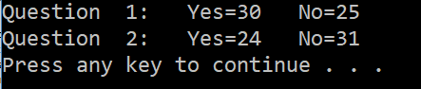

**Considerations:** Take time to look at the example on pages 718 of 719 the Murach text. Note that you must reference the .Net support for XML. The start of the code should include the following line:

using System.Xml;

Further, while the example on 719 is a good start, keep in mind that you have two levels of the file your application must look at. First, it must glean the value for the “Id” attribute of the question. Then it will need to examine each <response> element for its value. You should take time to research the following methods :

*Create

*ReadToDescendant

+GetAttribute (String) <https://docs.microsoft.com/en-us/dotnet/api/system.xml.xmlreader.getattribute?view=netframework-4.7.2>

*ReadElementContentAsString

* indicates description is in Murach text

+ indicates you may need to research Microsoft documentation online or use the help in visual studio